SAP Destinations

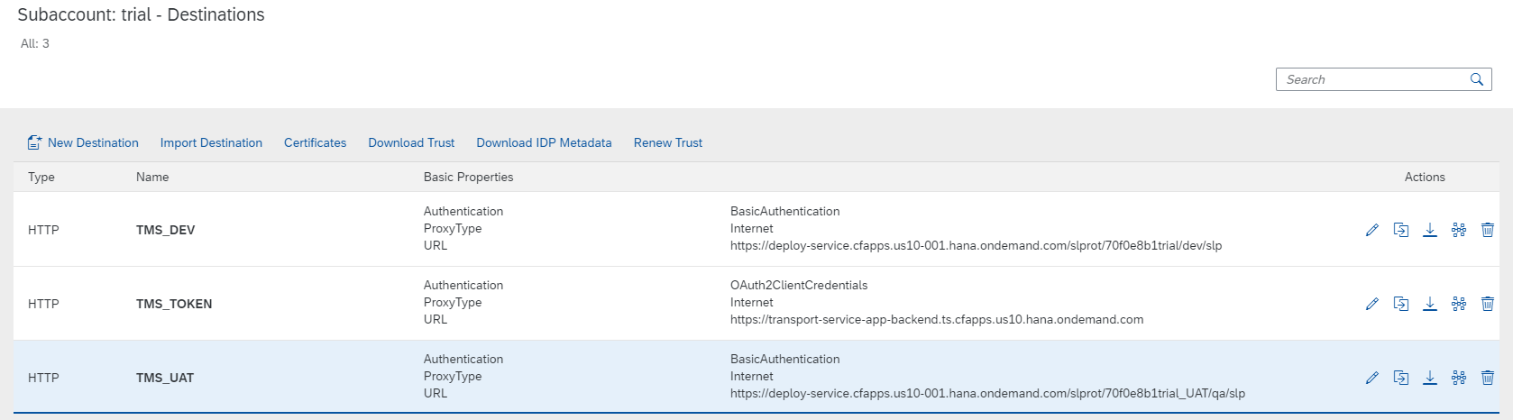

SAP Subscription and Instance

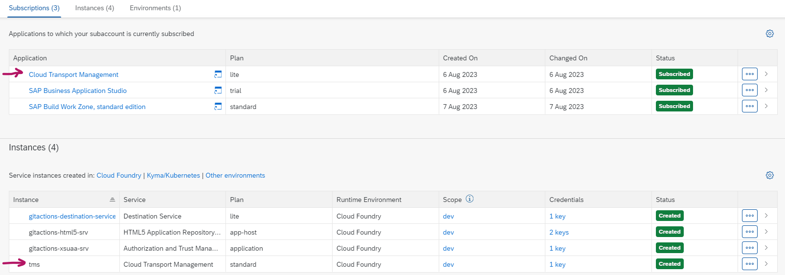

SAP TMS Node

GitHub Actions

name: Deploy to Cloud Foundry

on:

push:

branches:

- main

jobs:

build:

runs-on: ubuntu-latest

steps:

- uses: actions/checkout@v2

- name: Use Node.js

uses: actions/setup-node@v1

with:

node-version: 16

- name: Install MTA Build Tool

run: npm install

npm install -g mbt

- name: Build MTA

run: mbt build -p cf

- name: Upload Artifact

uses: actions/upload-artifact@master

with:

name: mta

path: ./mta_archives/gitactions_0.0.1.mtar

deploy:

needs: build

runs-on: ubuntu-latest

steps:

- name: Download Artifact

uses: actions/download-artifact@master

with:

name: mta

path: ./

- name: Get MTA path

run: |

ls -ltr

echo {{ github.workspace }}

- name: Install CF

run: |

wget -q -O - https://packages.cloudfoundry.org/debian/cli.cloudfoundry.org.key | sudo apt-key add -

echo "deb https://packages.cloudfoundry.org/debian stable main" | sudo tee /etc/apt/sources.list.d/cloudfoundry-cli.list

sudo apt-get update

sudo apt-get install cf8-cli

cf install-plugin -f https://github.com/cloudfoundry-incubator/multiapps-cli-plugin/releases/latest/download/multiapps-plugin.linux64

- name: CF login

run: cf login -a ${{ secrets.CF_API }} -u ${{ secrets.CF_USERNAME }} -p ${{ secrets.CF_PASSWORD }} -o ${{ secrets.CF_ORG }} -s ${{ secrets.CF_SPACE }}

- name: Deploy to Cloud Foundry

run: |

cf deploy ./gitactions_0.0.1.mtar

- name: CURL

run: |

curl -V

sudo apt-get install jq

- name: Token

run: |

TOKEN=$(curl -XPOST -H 'Accept: application/json' -u '${{ secrets.TMS_CLIENTID }}:${{ secrets.TMS_CLIENTSECRET }}' -H 'Content-Type: application/x-www-form-urlencoded' '${{ secrets.TMS_TOKEN }}?grant_type=client_credentials&response_type=token' | sed -n '/ *"access_token": *"/ {s///; s/{//g ;s/".*//; p; }')

echo $TOKEN

echo '${{ secrets.TMS_URL }}/v2/files/upload'

echo $TMS_URL'/v2/files/upload'

fileId=$(curl -s --location --request POST 'https://transport-service-app-backend.ts.cfapps.us10.hana.ondemand.com/v2/files/upload' --header "Authorization: Bearer $TOKEN" -F 'file=@./gitactions_0.0.1.mtar' | jq -r '.fileId')

echo $fileId

response=$(curl -s --request POST 'https://transport-service-app-backend.ts.cfapps.us10.hana.ondemand.com/v2/nodes/upload' --header "Authorization: Bearer $TOKEN" --header "Content-Type: application/json" -d '{"nodeName": "TMS_DEV","contentType": "MTA","storageType": "FILE","entries": [{"uri": '"$fileId"'}], "description": "export/upload of 1 MTA"}')

echo $response